**The National Institute of Engineering**



(An Autonomous Institution affiliated under

Visvesvaraya Technological University, Belagavi)

Manandawadi Road, Mysuru – 570008

# WASTE COLLECTION AND SEGREGATION

**“Clean India 1.0 Campaign”**

*As a partial fulfillment for the award of Degree in Electrical & Electronics Engineering*

**A public service activity for the award of activity points organized by**

## MYSURU CITY CORPORATION

**Submitted by A Madhukar – 4NI19EE001**

## Under the Guidance of

**Ms. Ashwini G**

Assistant Professor

Department of Electrical & Electronics Engineering

NIE, Mysuru



**DEPARTMENT OF ELECTRICAL & ELECTRONICS ENGINEERING**

The National Institute of Engineering

Manandawadi Road, Mysuru – 570008

## The National Institute of Engineering,Mysuru – 08

**Ms. Ashwini G**

Assistant

professor

Engineering



(An Autonomous Institution affiliated under Visvesvaraya Technological University, Belagavi)

**Department of Electrical & Electronics Engineering**

## CERTIFICATE

This is to certify that the activity entitled **“WASTE COLLECTION AND SEGREGATION”** is a bonafide work carried out by **A Madhukar** bearing **USN: 4NI19EE001,** student of **T h e** **National Institute of Engineering** inpartial fulfillment for the award of **Bachelor of Engineering** in **Electrical & Electronics Engineering** of the Visvesvaraya Technological University, Belagavi during the year 2022-23. It is certified that all theory/practical/corrections/suggestions indicated for Activity Points have been executed under the directions of **Ms. Ashwini G** Mam**.** The activity report has been approved as it satisfies the academic requirements in respect of AICTE Activity Points prescribed for the said degree.

**Dr. Pradeepa H**

Head of the Department

Dept. of Electrical & Electronics Dept. of Electrical & Electronics

Engineering

The National Institute of Engineering The National Institute of Engineering

Mysuru-570008 Mysuru-570008

**Dr. Rohini Nagapadma, Ph.D.**

The National Institute of Engineering Mysuru - 570 008

|  |  |
| --- | --- |
| A MADHUKAR (4NI19EE001) |  |

## DECLARATION

I, **A Madhukar,** bearing **USN: 4NI19EE001**, student of VIII semester B.E., Department of Electrical

& Electronics Engineering, **The** **National Institute of Engineering**, Mysuru declare that the AICTE

Activity Project work entitled **“WASTE COLLECTION AND SEGREGATION”**, has been duly executed by me, organized by Mysore City Corporation, under the guidance of CADA Office and Ms. Ashwini G, Asst Professor, Department of Electrical & Electronics Engineering, **The** **National Institute of Engineering**, **Mysuru**. The Activity report of the same is submitted in partial fulfillment of the requirement for the award of a Bachelor of Engineering degree in the Department of Electrical & Electronics Engineering by Visvesvaraya Technological University, Belagavi during the year 2022- 2023.

**Date:**

**Place:** Mysuru **Signature of Student**

## ACKNOWLEDGEMENT

The satisfaction that accompanies the successful completion of the project report which would be complete only with the people who made it possible, whose report rewarded the effort with success of AICTE Activity.

We are grateful to **The** **National Institute of Engineering** for giving us an opportunity to enhance our knowledge through the activity.

We express our sincere thanks to **Dr. Rohini Nagapadma**, Principal, NIE, Mysuru for providing us an opportunity and means to present the activity.

We express our heart full thanks to **Dr. Pradeepa H,** Associate Professor and Head, Department of Electrical & Electronics Engineering, NIE, Mysuru for encouragement in our project work, whose cooperation and guidance helped in nurturing this project report.

We would like to express profound thanks to the activity guide **Ms. Ashwini G, Asst Professor**,

Department of Electrical & Electronics Engineering for the keen interest and encouragement in our AICTE Activity.

We are grateful for **Mysuru City Corporation** for providing us this opportunity. We extend our thanks to the **CADA Office, Mysuru** for their effort and endurance to bring out the best in us.

Finally, we would like to thank our family members and friends for standing with us through all times.

|  |  |
| --- | --- |
| 1.  2.  3.  4.  5.  6. 7. | **TABLE OF CONTENTS**      **ABSTRACT ..........................................................................................................................2**  **NECESSITY OF AICTE ACTIVITY…………………………………………………….…3**  **PLACE OF VISIT ............................................................................................................... .4**  **INTRODUCTION ................................................................................................................5**  **PHOTO GALLERY .............................................................................................................6**  **WASTE COLLECTION ......................................................................................................7**  **CONCLUSION .....................................................................................................................8** |
|  | 1 | D e p a r t m e n t o f E l e c t r i c a l & E l e c t r o n i c s E n g i n e e r i n g |

## ABSTRACT

*Waste Collection and Segregation* activity was organized by the CADA Office, Mysuru in the month of **December 2022** for the duration of **2 weeks**. A total no. of 16 volunteers who are final year students of the Electrical & Electronics Engineering department, NIE, Mysuru joined the program. The place of visit was the CADA Office premises & Graveyard at Vishveshwara Nagar, Mysuru. During the activity, the volunteers were instructed to gather plastic and glass waste and separate them in a shed near the parking area for the CADA Office premises & Graveyard at Vishveshwara Nagar, Mysuru.

This report briefs out the work that was done by the volunteers during the period of this activity.

## NECESSITY OF THE AICTE ACVITITY POINTS

AICTE Council has mandated all the 4-year Technical Degree Enrolled students to Earn 100/75/50/25 Activity Points as per the Instructions.

Today, India has seen enormous development in Urban Infrastructure. Except for the pollution and increased expenses for lifestyle, Urban India has all basic infrastructures such as Education, Health, Transport, Employment, Food, and Special Services at reachable levels.

At the same time, Rural India has not seen any development in the accessibility of basic infrastructures. They have to travel a long distance to access even a small basic infrastructure. Though pollution and expenses for lifestyle is very less in Rural Areas, people are migrating to the Urban areas as they need Basic Infrastructure than the other facilities available in Rural India As per the experts, if at all Urban India has seen enormous development it is due to the

* Engineering Solutions 
* Engineering Implementations 
* Engineering Employments Though engineering contribution is more in the development there are other segments that contributed to the sustainable Urban Infrastructure such as 
* Health 
* Education 
* Transport 
* Dwelling Places  • Government Policies 

This is a motivational concept by AICTE to bring Social Innovation in Engineers at their education level to

* Address the Social Challenges of India 
* Propose a practical solution to such challenges 
* Bring more Social Innovations and Research 
* Blend the available technology for effective solutions AICTE Activity Points is very essential in shaping India for the sustainable life style 

**PLACE OF**

**VISIT**

*C*

*ADA Office & Graveyard at Vishveshwara Nagar,*

*Mysore*

For our activity, we were instructed to

search for plastic and glass bottles around the premises of the

C

ADA Office & Graveyard at Vishveshwara Nagar, Mysuru

. We were given

biodegradable plastic

bags

and were asked to

collect

all

the

bottles

and plastic

waste

we

could

find,

and

then

subsequently

separate

them

in

the open space

.

*Waste*

*Collected*

*and Segrega*

*ted*

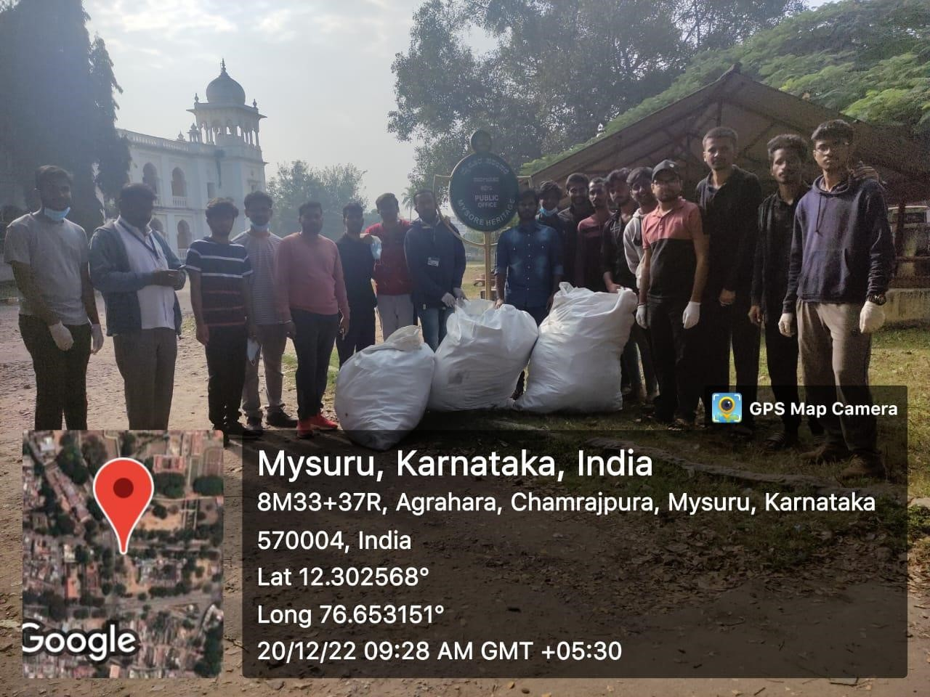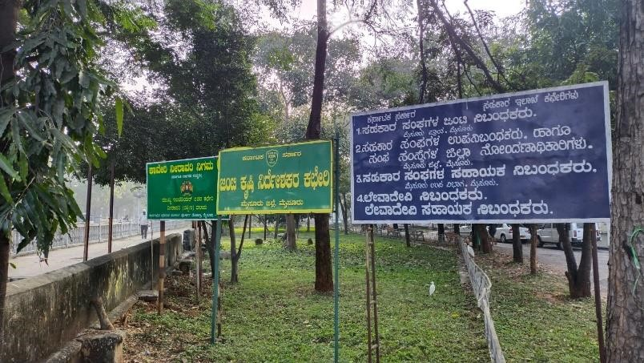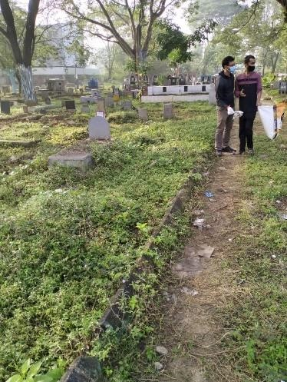

## INTRODUCTION

It is well known that India houses a population of over 1.3 Billion people. With a population as large as this, proper enforcement of law and order is more complex and tedious than in other countries with a smaller population relative to India. Nowhere is this more obvious than in the state of waste disposal in many semi-urban and urban areas, where the density of the human population is the highest. As a consequence, any popular tourist destination in these semi-urban and urban areas tends to have large congregations of people, and unfortunately, a large number of people throw their waste wherever they want, even if there are dustbins designated for waste disposal present on the premises. One such government office is CADA Office and another one is the graveyard at Vishveshwara Nagar, Mysuru where a lot of waste is disposed of irresponsibly in the area by all the visitors, even though designated dustbins are present nearby. To combat this issue, an activity was set up where volunteers scoured the premises for waste items such as plastic and glass bottles, collected them, and segregated them in a waste collection and segregation center, where the waste would be collected and stored till the local Gram Panchayat recycles the waste.

### REPORT ON WASTE COLLECTION AND SEGREGATION ACTIVITY

* The activity was conducted in the month of December 2022 for the duration of two weeks at two locations (viz., CADA Office and Graveyard at Vishveshwara Nagar, Mysuru).
* On every day of the activity, a subgroup of 4-5 volunteers of the group was instructed to arrive on the premises at 7:00 am.
* The volunteers were then provided with one garbage bag per person and were instructed to survey the locations around the Office and collect any disposed plastic and glass bottles that they found on the premises.
* Once a garbage bag was filled, the volunteer would take the bag to a waste segregation area, and then segregate the waste found in the pile.
* After this, the volunteer would then set out again to search for more bottles, plastics, papers and waste.
* All the volunteers in the subgroup were instructed to conduct the waste collection and segregation activity for around 2 and a half hours.
* Each subgroup among the 16-member group conducted the activity for at least 2 days in two locations in the entire duration of the activity points program.

## PHOTO GALLERY

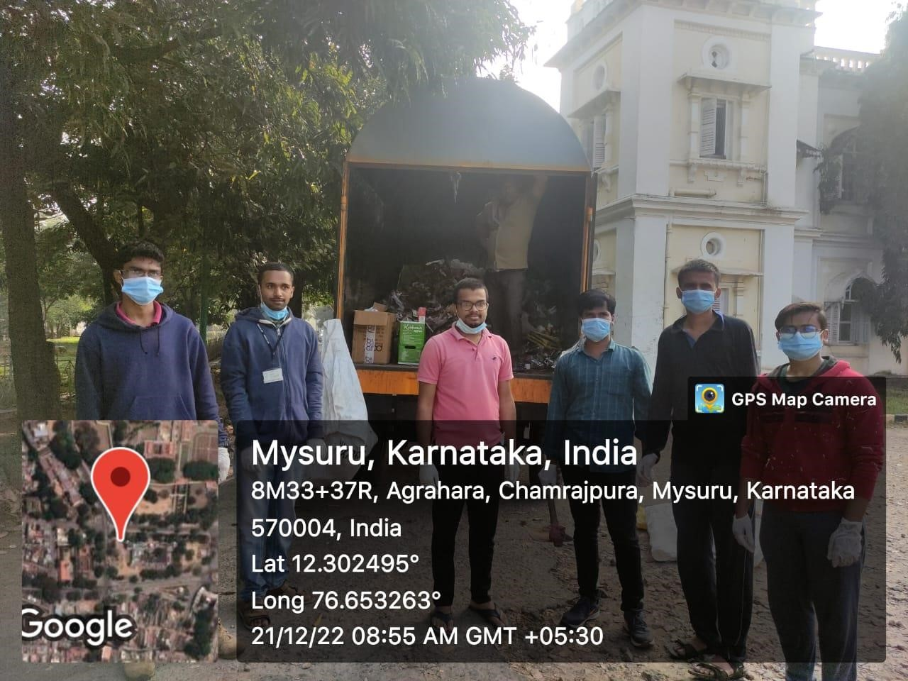

*Volunteers for Waste collection and Segregation Activity*

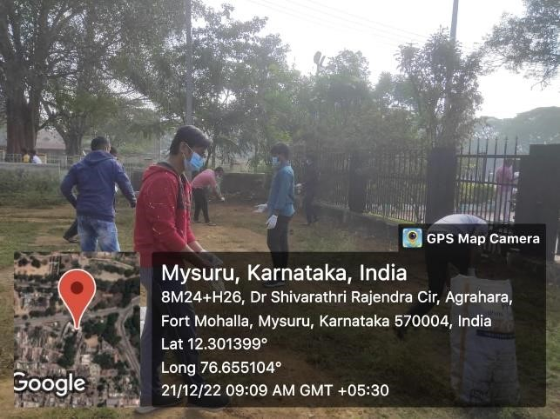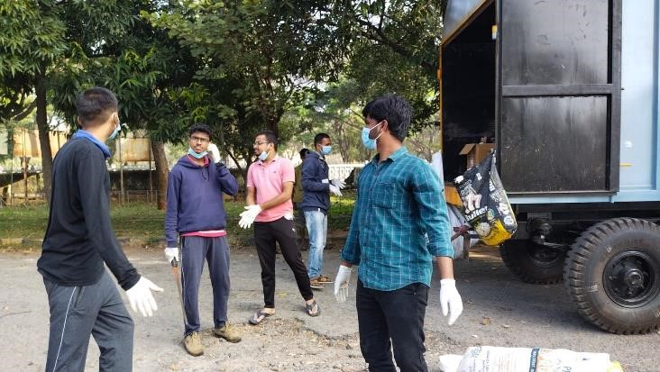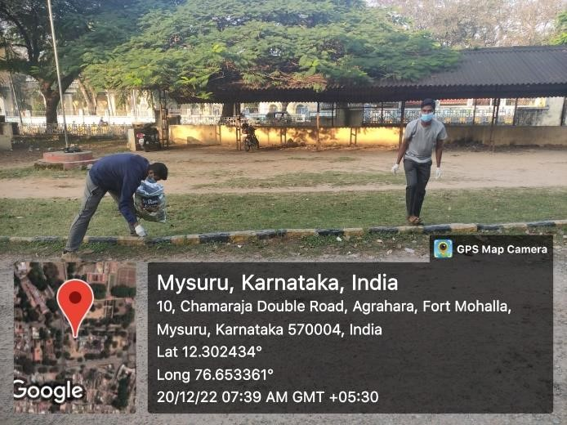**WASTE COLLECTION**

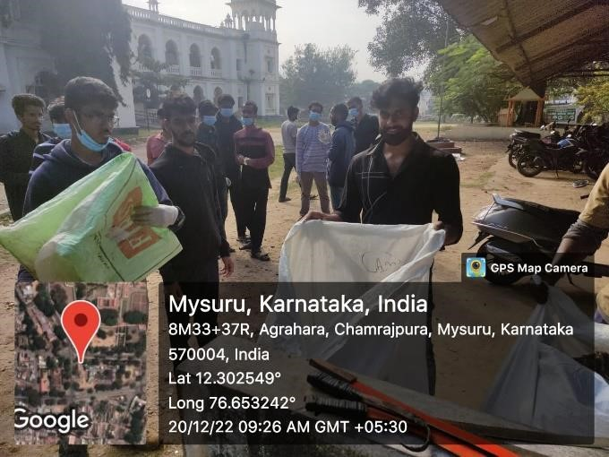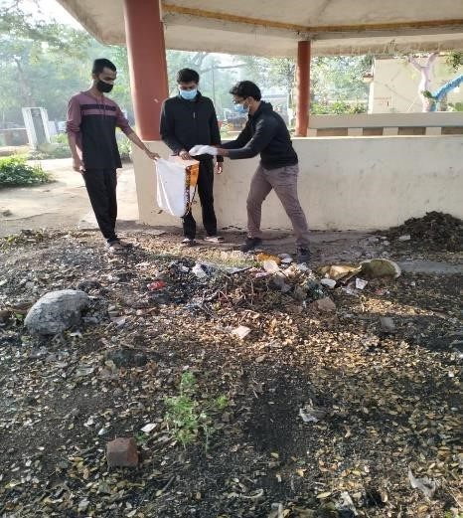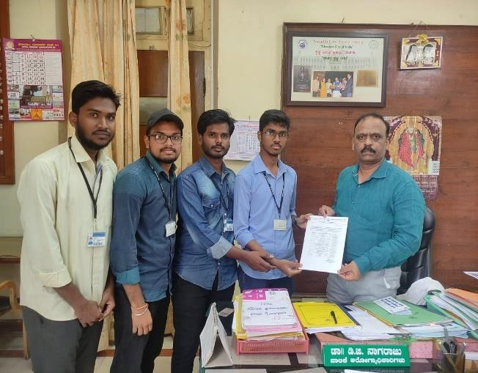

## CONCLUSION

Essentially, it is important to understand that engineers do not just work with machines, designs or circuit boards, and engineering doesn’t only require a good understanding of science and mathematics. Engineering needs to be understood in the context of its role in society, and one’s role as an engineer has to be understood in the context of one’s work within a company, and ultimately within society. As engineer, one may be involved in negotiations; one may become a manager, supervising the work of a team of engineers; one may have special responsibilities to ensure that work is safe, or to ensure it does not damage public hygiene, the environment, or the country’s reputation. This program helped us greatly, to understand the necessity of teamwork and taught us the importance of social responsibility.

Our Self-encouragement and also guidance from our Mentors were substantially required for the success of this activity and so, we would like to thank and cordially acknowledge the people who have been instrumental to this endeavor and without whose support it would not have been possible with the successful completion of this activity.